Samantha Branham
Professor Vaughn
English 2089
3 February 2017

Chop Suey for the Soul: My Poetic Journey
I’ve always hated Dr. Seuss. My parents used to read me Green Eggs and Ham because the one character is called Sam-I-Am, but I hated being called Sam and I hated eggs and ham. For the first decade of my life, I just hated poetry in general. Maybe it was that particular story or maybe it was the countless Shakespeare sonnets I had to read in school. Regardless, my distaste for poetic verse did not turn out to be a chronic condition. Rather on the contrary, poetry soon came to be one of my favorite things.
I very clearly remember writing my first poem. I was ten years old: short, scrawny, freshly out of fourth grade, and firmly in the middle of puberty. Even better, I had just moved 750 miles from the liberal coasts of Massachusetts to the conservative cornfields of Indiana. Ten-year-old me liked to write in that vague way that all ten year olds “like” to write but I was intensely passionate about the work I produced. Honestly, I hadn’t ever truly written anything of any consequence, but my fourth grade teacher took notice of my interest. This was notable since I had spent most of that year in a quiet ball of nerves, sick to my stomach every morning at the thought of having to catch the bile-colored bus to a tiny school where I had next to no friends and even less motivation. So, nearing the end of the school year from hell, my teacher called me to her desk and gleefully produced a glossy brochure for the annual creative writing summer camp at Butler University. I took one look at the cheery boldfaced type and the pictures of shiny, smiling people and decided that sounded like the worst possible way to spend a week of my summer. I flashed my best impression of a winning smile and gave a fake and flaky “thanks” to my teacher, while I mentally tossed that paper right into the trash. Of course, my parents were thrilled with the idea and signed me up right away.
Each day of camp was themed. My camp counselor started off our “Poetry Day” by projecting a single image on the tarp-like screen at the front of the room. I waited with infinite patience as the humming box bored its beam of light at the screen, illuminating the wall in a wash of blue before slowly fading to an image of a painting, suspended in midair like the many thoughts that were supposed to be drifting through our heads. I flipped the frayed and fibrous cover of my notebook and stared at the endless expanse of snowy white, struck through here and there by the sable veins of the margins.
The painting was an early Edward Hopper work, called Chop Suey (Figure 1). It’s a lovely piece, balancing oranges and blues using thick paint and silky strokes. Such colors rarely work for artists, though some artists like Hopper and Vincent van Gogh are notably able to make such harsh and contrasting colors look beautiful overlaid with one another. Chop Suey has such a stillness to it, though it’s clear from the context of the painting that the room depicted in this work is a hub of endless chatter and ceaseless noise. The women in the painting face off with each other, silent, while the world spins around them.
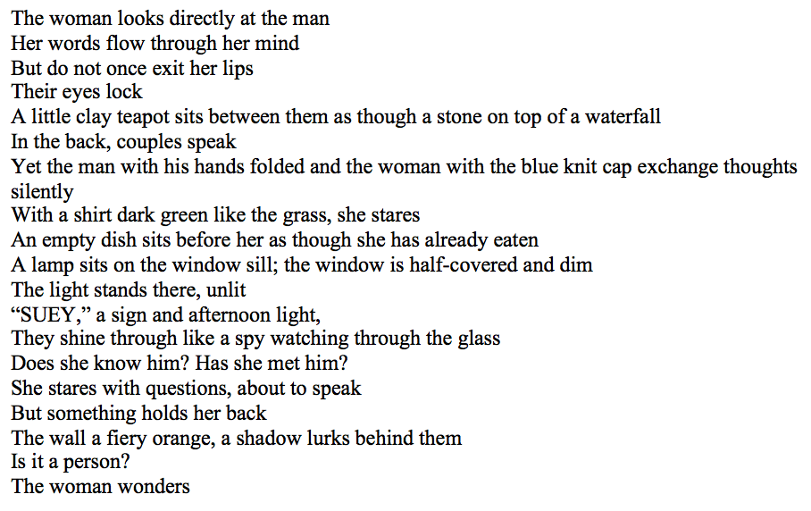
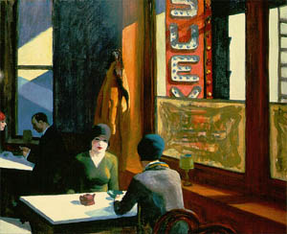
Of course, I didn’t process any of this information at the time (in fact, I mistakenly assumed the woman facing away from the viewer was actually a man). Instead, I gazed at my pencil and darted my eyes back and forth between the painting and my blank notebook. After what was probably five minutes but felt like maybe hours or days, I felt a shift within myself. The metaphorical cogs in my brain began churning once again and the words floated to the surface of my brain like breadcrumbs in soup. I felt at once overcome with emotion and my hand began to frantically move across the page. Thus, in an instant, I became a poet.
Figure 2 My first poem, from summer 2009
Figure 1 Chop Suey (1929) by Edward Hopper

It’s difficult to pinpoint who or what exactly caused this change inside me. Perhaps, initially, it was just the whole situation of having to come up with a creative piece on the spot that served as a sort of literacy sponsor for me. Maybe sweltering in the sticky heat of that stuffy classroom incubated the dreams and stories inside my head into something more. And of course I wanted to impress my counselor and fellow camp-goers with my writing prowess.
That week was an instrumental time in developing my love of writing. The five days I spent flitting between the cold concrete of the university walls and the damp refuge of the campus gardens were a blur of ideas and frenetic writing. Malcolm X said in his autobiography that during his time in prison, he “would guess [he] wrote a million words” (121). I felt very similar during those initial few days after writing my first poem. I felt like I couldn’t stop pushing the words out of me. I then began to read the poetry of all the greats: Edgar Allan Poe, Emily Brontë, Sylvia Plath. Like Malcolm, I felt that “no university would ask any student to devour literature as I did when this new world opened to me” (122). I swallowed those poems whole like I had been starving for months on end. The greatest incentive I ever had for learning to write and consume poetry was reading the words of those I saw to be the best at scratching out their feelings in the shape of letters and sentences. Poe and Plath and Brontë were some of my most influential sponsors on this journey to become literate in the ways of the poetic arts. I knew if I tried hard enough, I could write just like them and I could do it better.
Later, I began to realize that the art itself served as a literacy sponsor for me. During that same summer writing camp, we walked to the Indianapolis Art Museum and were permitted to wander around for hours and write about what we saw and felt. I remember sitting on smooth, hard benches with my fingers curled around a golf pencil (because they didn’t allow pens in the galleries) as I described the brushstrokes and shadows and shapes of the art surrounding me from every angle. As I’ve gotten older, I’ve come to appreciate the beauty in art more fully, and it’s easy to draw parallels between the feelings I get when looking at a painting that amazes me and the feelings I get when I manage to encapsulate my feelings in writing. Incidentally, my interest in writing poetry about artwork led to me becoming interested in learning about the art itself further down the road, effectively serving as the catalyst for a new kind of personal literacy.
I have struggled with my mental health for most of my life. Though I remained undiagnosed for several years after beginning to write poetry, the discord in my head often found its way to the page even then. Many people would rather not believe their mental illness has ever been of use to them, but for me I consider it one of the greatest contributors to my becoming literate as a poet. Many of the works of art we hold most dear were created by an artist or writer struggling with their own brain. I know, for me, my best work has always seemed to come out of my darkest moments.
In terms of my personal literacy practices, my methodology is a very “wash, rinse, repeat” process. I have found that the simple act of sitting down with my journal or my laptop and writing out my thoughts and ideas is the best way for me to produce poetry. I have also found that even jotting down snippets and fragments of a potential poem is beneficial. I frequently find myself opening the notes app on my phone and typing in a phrase that’s been stuck in the recesses of my mind. Later, I am able to combine these scraps into a larger body of work. This is extremely beneficial when I am suffering from writer’s block.
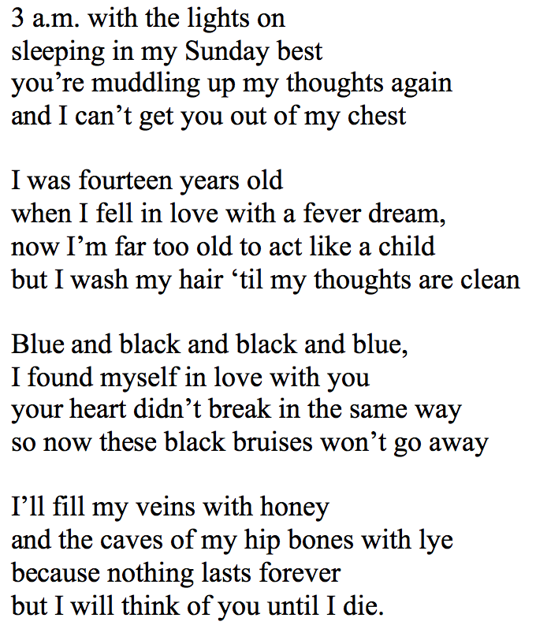
I additionally write poetry when I am struggling with something in my personal life, be it having a bad day or having an argument with someone. In this way, I use my writing as an emotional outlet and it has so far proved instrumental in being a way for me to ‘talk’ to someone when I don’t have the necessary words to actually have a conversation with some other person in my life. Stephen King compared writing to telepathy in his essay, “What Writing Is.” There have been many occasions where I have wished the subject of my poem could somehow hear what I’m trying to tell them without seeing the poem; I have wished we, too, could be “having a meeting of the minds” (King 106).
The catharsis that writing poetry has always provided me with is perhaps the greatest sponsor for my fluency with the skill. I don’t believe at all that I am a prodigy when it comes to writing, but I believe I have become good at it through practice and repetition as I have tried to put my thoughts into words. Sherman Alexie said that his “love [of reading] had only one purpose. I was trying to save my life” (131). Like him, my writing was born out of “equal parts joy and desperation” because, though I loved to write, it was as necessary as breathing at times (Alexie 131). I was trying to save my own life by making sense out of it. I was trying to find an outlet that could bandage my wounds and rescue me.
Figure 3 A recent work, from January 2017
I think writing of any kind is a very personal sort of literacy. Not all writing is meant to be shared and most people would rather not share any of it. For me, I often feel bashful or self-conscious about my writing. I refrain from sharing my most personal thoughts because they are, after all, mine. However, I feel that writing should be shared from time to time, as long as the writer feels comfortable. I have found that sharing my own poetry (after scouring and nitpicking it half to death) is its own kind of catharsis. One is truly able to connect with another person when sharing this kind of personal information. The value of my writing comes from my own personal satisfaction with it, yes, but also when it allows me to connect with someone else. Much of my recent growth when it comes to my writing literacy is learning to be comfortable with sharing my work. It’s not the easiest thing in the world but it feels so genuinely good to have someone read my poetry and say, “I enjoy this and I understand what you mean.” Art is personal but the experience of sharing it is intrinsically rewarding.
Four years after writing my first poem, I stood at a foreboding oak podium at the front of a lecture hall in the pharmacy building at Butler University. It was the last day of camp and, thus, time for the time-honored tradition of sharing something we had written that week. I felt cold sweat on the inside of my palm as my fingernails etched half-moons into the skin. The room was a bubble of chatter and laughter as my audience began to settle down. The screechy, starchy feedback of the microphone hissed out into the stuffy air as I introduced myself. I cleared my throat to keep my voice from trembling as I began.
I focused on my breaths as I read the best poem I had written that week, trying to keep enough air in my lungs to reach the end of the page. The fluorescent lights in the room were buzzing bright as I looked up to glance at the audience, my family among them. When I finished, everyone clapped politely and I tiptoed back to my seat as the next presenter began reading her own work. As I began to come down from my adrenaline high, a breezy calm passed through my body. The girl sitting next to me leaned over. “That was really good,” she whispered.
“Thank you,” I replied.
When it was time to leave, my family congratulated me as well. They were proud of me for creating my own little work of art. I was proud of myself for having the courage to speak my thoughts to a lecture hall full of my peers. Writing poetry has kept me sane in so many ways and has taught me to be brave in acknowledging and sharing my thoughts and feelings. The five-cent notebooks that were my Bible each summer have since been lost to the sands of time, but their contents will never quite leave my mind.

Works Cited
Alexie, Sherman. “The Joy of Reading and Writing: Superman and Me.” Writing about Writing: A College Reader (2nd ed.). Ed. Elizabeth Wardle and Doug Downs. Boston: Bedford/St. Martin’s, 2014. 129-131. Print.

King, Stephen. “What Writing Is.” On Writing. New York: Scribner, 2000. 103-107. Print.

X, Malcolm. “Learning to Read.” Writing about Writing: A College Reader (2nd ed.). Ed. Elizabeth Wardle and Doug Downs. Boston: Bedford/St. Martin’s, 2014. 120-126. Print.

Additional Poems
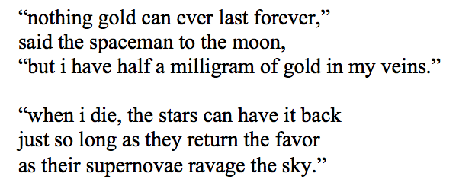
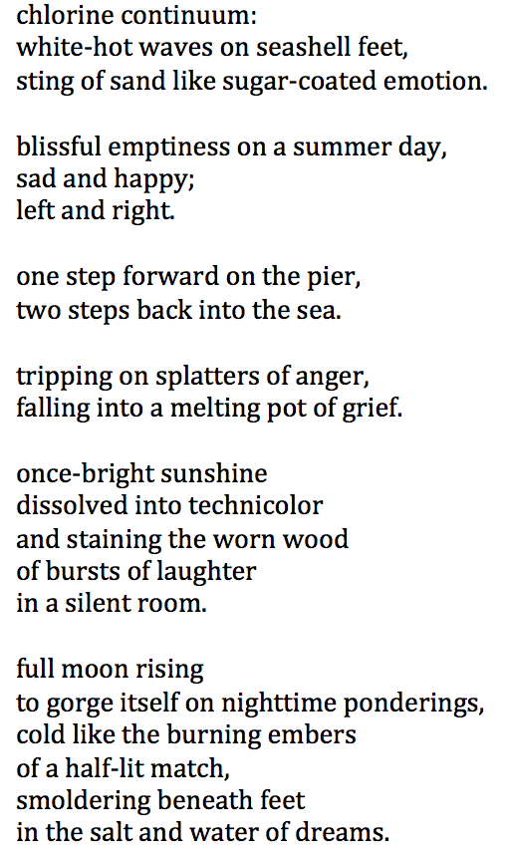
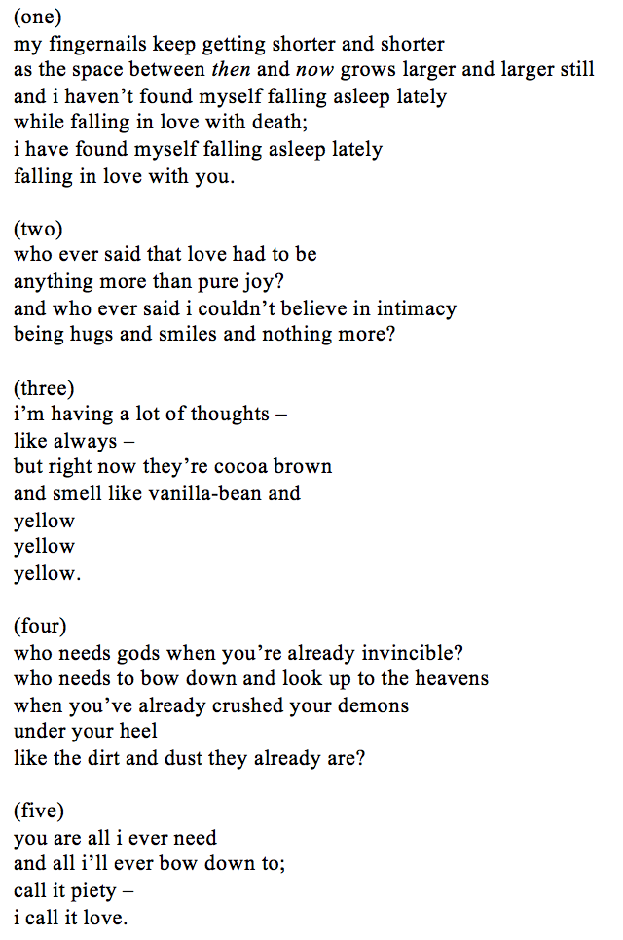
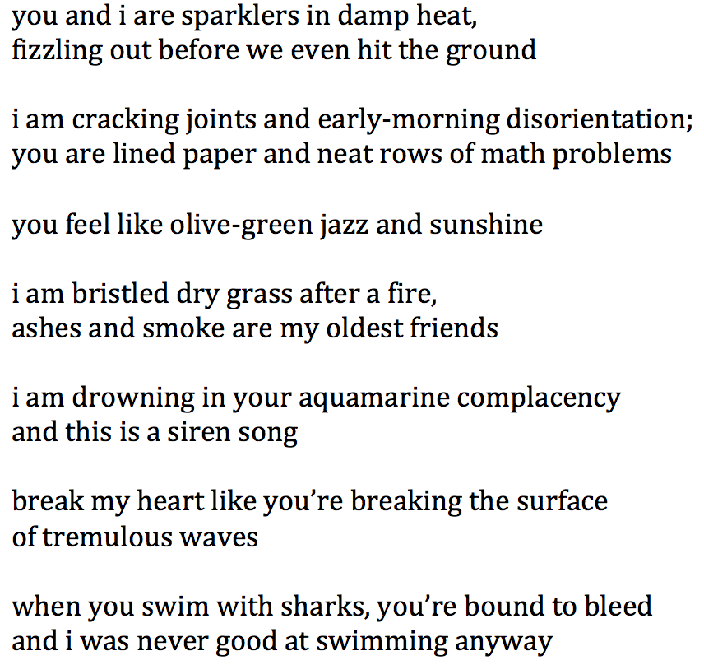
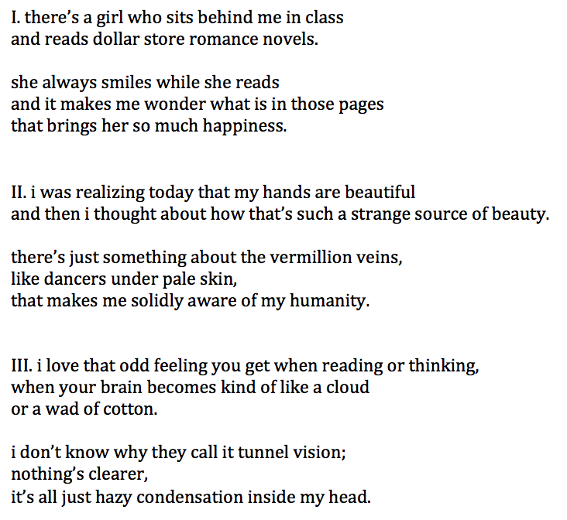
Figure 4 Poem from August 10, 2014
Figure 8 Short poem from January 15, 2017
Figure 5 Poem from December 18, 2014
Figure 7 Poem from August 19, 2015
Figure 6 Poem from February 1, 2015

