Samantha Branham
Professor Vaughn
ENGL 2089
12 April 2017

Progressing toward Professionalism: The Experiences of Direct-Admit Nursing Students
What do nursing students actually do? The roles and characteristics of a nursing major are largely ambiguous to the general public. There is the assumption that it is something like a “diet med school,” where students go to school for two or four years and come out on the other end with a license and a degree, wholly professional and knowledgeable in their field of study. The end product is largely visible. It’s just the process of getting there that remains a bit mysterious.
It’s not that there hasn’t been research done on the subject. Anyone with Internet access and a little free time can find a multitude of research studies about the experiences of graduate nursing students of all calibers: the need for skilled nurse practitioners to precept graduate students (Logan et al., 2015), the advantages of using simulations to educate students in Family Nurse Practitioner (FNP) programs (Haut et al., 2014), the value of emphasizing writing skills for students working toward a Doctorate of Nursing Practice (DNP) (Ryan et al., 2013), and many more. Research has also been done on undergraduate nursing students’ experiences, though the data is far more generalized than that for advanced practice nursing students. There exists information on the importance of certain courses and styles of pedagogy for undergraduate students (Leach et al., 2015; Craft et al., 2016) and on certain demographics within the student nurse population, such as those with disabilities (McCulloh and Marks, 2016). Yet, the literature leaves out one very specific and significant population: direct-admit students in Bachelor of Science in Nursing (BSN) degree programs. In fact, in all the time I spent searching through health science-related databases, I found not a single research study or journal article that focused on the distinctions between the various BSN tracks.
These degree tracks often fall into one of two categories: a direct-admit path, which means the nursing student is admitted directly into the nursing program upon acceptance to the university, and a “regular” path, which involves typically one to two years of prerequisites that the student must complete before applying to the college of nursing at the institution he or she attends. I am currently in a direct-admit program, but even I was unsure of the difference between the various BSN tracks until I was already admitted to school and part of the program. I find it curious and startling that little to no research has been done on the experiences of students enrolled in these differing programs, nor on the comparison of said experiences and the degree tracks themselves. Thus, I chose to conduct my own research specifically on the discourse community of direct-admit BSN students.
My first step in conducting this research was to determine whether this group of students could effectively be called a discourse community. According to John Swales’ research on the subject, a discourse community:
- Has a broadly agreed set of common public goals.
- Has mechanisms of intercommunication among its members.
- Uses its participatory mechanisms primarily to provide information and feedback.
- Utilizes and hence possesses one or more genres in the communicative furtherance of its aims.
- Has acquired some specific lexis [in addition to its genres].
- Has a threshold level of members with a suitable degree of relevant content and discoursal expertise (Swales 220-222).
Direct-admit BSN programs, in general, exist to educate students in such a way that they are prepared to graduate and achieve licensure by passing the standardized NCLEX-RN exam upon graduation. This is a common and universal goal of such programs and it is a goal that is fully available to the public through a number of media. In fact, the University of Cincinnati’s BSN webpage lists the program’s objectives directly:
- Apply relevant theories from nursing and related natural and behavioral sciences as a foundation for planning holistic care to enhance modify or support population focused health care in various environmental contexts.
- Demonstrate clinical judgment while providing holistic care as a member of the interprofessional team in various environmental contexts.
- Employ effective communication and collaboration for professional nursing practice utilizing information management and patient care technology.
- Demonstrate leadership to effectively implement evidence-based interventions that promote patient safety and quality improvement initiatives within the context of the interprofessional team.
- Apply nursing process to address the health of diverse populations in the provision of evidence-based, comprehensive nursing care.
- Educate diverse populations in health promotion, disease prevention, maintenance, and health restoration.
- Use scholarly inquiry to guide professional practice.
- Demonstrate leadership in health policy, advocacy, and management of holistic care.
9. Apply professional standards of practice incorporating legal, ethical, and resource management (University of Cincinnati).
The students in this program have various ways of communicating with one another, including during class, at review sessions, during LC (learning community) meetings in their freshman year, through social media, etc. Feedback and information is provided in the classroom setting as well as within nursing-oriented clubs and between students as they interact and discuss class material. The genres inherent in this community are varied as well and include textbooks, assignments and class presentations, text messages or social media postings among members, and many more. As a medical-based community, there is a very specific lexis the members must develop. Medical terminology including acronyms (DNR, PICC, HESI, NCLEX) and other terms (distal, parietal, zygomatic process) is a part of students’ vocabulary. Finally, as a (typically) four-year degree program, there is diversity in the members of this community, from incoming freshmen to graduating seniors, not to mention the hordes of registered nurses who have already graduated and attained their BSN degree. There is a threshold number of students as well, due to the number of available spots for clinical rotations. The community of direct-admit BSN students can then, unequivocally, be considered a discourse community.
After establishing this, I set about actually conducting my research. To do so, I interviewed a current nursing student in a direct-admit BSN program as well as a registered nurse who graduated from this type of program several years ago. I also observed a review session conducted by a group of current direct-admit students as they collaborated to prepare for several upcoming exams. Additionally, I surveyed a group of students to get their input and some quantitative data about the discourse community.
One of my main points of interest in studying this discourse community was whether there were any notable advantages and/or disadvantages to being in this sort of program. Did students choose a direct-admit program because of a particular benefit? Are students who are not in a direct-admit program “missing out”? I conducted an anonymous online survey of several direct-admit BSN students here at the University of Cincinnati to gauge their feelings on the subject. One question asked them to name one particular advantage they felt they had by being part of this program. Another question asked them to name one particular disadvantage.
There was a common thread among the answers. Many participants felt that being in a direct-admit program gave them some peace of mind. The most common answer I got was that these students didn’t have to worry about their future in the program: “not worrying about getting accepted,” “not having to worry about applying sophomore year,” “don’t have to worry about not having a spot in the program,” “not worrying about having to transfer,” “don't have to take the test to get in,” “guaranteed spot in clinical” (Branham). As direct-admit students, they each have a reserved spot for clinical rotations in sophomore year, so long as they pass their freshman courses. One participant named a more broad advantage: “being able to graduate with a degree after just 4 years” (Branham). Of course, this would also hold true in a traditional BSN program.
The participants gave more varied answers to my question about disadvantages of the program. Some students felt the additional responsibility was a burden: “you don't have much extra time because you're always studying,” “more expected of you.” Others felt having a guaranteed spot in the program allowed them to slack off somewhat: “taking for granted that we're already in the program,” “students don’t try as hard,” “less motivation” (Branham). These opposing answers could likely be attributed to individual personality and work ethic. Regardless, these answers seem to indicate that the disadvantages to being a member of this discourse community are merely superficial, especially compared to the security promised by being part of the community.
To get a more in-depth opinion on the matter, I conducted an interview with a student currently in the University of Cincinnati’s direct-admit BSN program. Julia Earnest is a freshman in the program, almost finished with her first year as a student nurse. Julia finds that the most apparent advantage of being in this community is the overwhelming support. In her experience, there are “so many people…who want you to succeed and who are doing their best to make sure you get there” (Earnest). In her first year as a college student, she has felt welcomed into this “heavy, supportive community,” mainly because she is a direct-admit student (Earnest). Julia’s feelings echo those of the students I surveyed in terms of the security of this degree program. She believes a major pro of being a member of the community is that it is “an encouraging and a helpful environment and there’s lots of certainty” because “you’re not competing with everyone you interact with,” like pre-nursing students do (Earnest).
Julia couldn’t think of any particular disadvantages of the program that stood out to her, though she acknowledged several costs of affiliation relating to her membership in the community. To assimilate into the direct-admit program, Julia has experienced a “loss of relatability” with her non-nursing peers, as well as a loss of “social interaction,” “free time,” and sometimes “full sanity” due to the intense workload inherent in her degree program (Earnest). She does not regret becoming a member of the community, however, regardless of things she has had to give up to assimilate.
I was curious whether the so-called benefits of being a direct-admit BSN student had any lasting impacts on former members of this community. Thus, I decided to interview someone who had already been through the program. Lynn Fialkow is a registered nurse who received her BSN degree in 1997. She entered into the BSN program at Indiana University as a pre-nursing student. She struggled to get into her prerequisite classes because they would fill up before she could enroll. The ensuing frustration led her to transfer to Valparaiso University, which had a direct-admit program. A BSN program is typically four years, but Lynn’s ended up being five years because of her trouble fitting in the prerequisite classes in time. This led not only to “feelings of frustration,” but it was also a “waste of money” (Fialkow). If she had known how hard it would be to complete prerequisites, Lynn would have chosen a direct-admit program from the start.
What’s more, hospitals are now very selective in the hiring process for registered nurses, especially when it comes to their education level. Recently, a local hospital in Lynn’s town has begun letting nurses go if they don’t have a BSN degree, regardless of how long they have been practicing. “They have more experience than me,” Lynn said during our interview (Fialkow). Yet, hospitals see BSN-prepared nurses as “very well-rounded,” especially those who have graduated from direct-admit programs, and nurses with associate’s degrees as less skilled and prepared (Fialkow). It’s important to note that this laying-off process is occurring during a worldwide nursing shortage (ICN). An obvious advantage, then, of being a BSN student in a direct-admit program is the promise of job security in future endeavors.
I additionally focused my research on the assimilation or enculturation processes of this community. A 2016 study by Martin Christensen and his colleagues, "Do Student Nurses Experience Imposter Phenomenon? An International Comparison of Final Year Undergraduate Nursing Students Readiness for Registration," examined the occurrence of the “imposter phenomenon” in undergraduate nursing students preparing to graduate. In their words, “preparing for graduation and the ‘real life-world’ of professional nursing practice invokes in many final year nursing students feelings of anxiety, depression and stress,” as well as “feelings of doubt, inadequacy and insecurity as to the expectations of the Registered Nurse role and responsibilities” (Chritensen et al., 2785). Sometimes termed “transition shock,” this phenomenon occurs in individuals at all stages in life who are facing a major shift in their role in society. I was curious if such a phenomenon occurred in first-year nursing students as well, especially those in direct-admit programs, where they had to deal with the transition to both being a college student and being in a professional program.
In my interview with Julia, she expressed feeling similar emotions as described in Christensen et al.’s study upon entering college. At the start, she saw her chosen college career as somewhat impermanent, in that “there was the sense of, like, ‘well I could still do other things and I don’t know if I’m gonna love it’” and thoughts of “’yeah, I’m in school for nursing but there are also, you know, how do I commit to one thing for the rest of my life right now?’” (Earnest). For Julia, the turning point came when she realized “these other people were all gonna be the nurses of 2020 and we’re all working toward the same goals and these are people who are going to be my colleagues,” which gave “such an intense sense of belonging” (Earnest). Still, her process of assimilating into the BSN program was fraught with insecurity:
“Coming out of high school, there’s this sense of, like, ‘oh, I’m young and I can do anything,’ but the second you make a decision, that limits you, and then you can’t do anything. I mean, you could, but it would be harder for you. And so it’s hard to go from, like, this big, open world with all of these options, which is a perception, not actually reality, to a very narrow focus: ‘This is what I’m doing, I’m going to be a nurse and I’m going to spend all my time working toward being a nurse and that’s going to be all my time and I better love it.’ You have to have that kind of mental shift from it being a choice you made to an actual part of you” (Earnest).
For Julia, coming to terms with the fact that she and her peers were all “in the same boat,” so to speak, helped her to feel less alone in her uncertainty coming into such a serious program. This camaraderie is something she may not have had, had she not been accepted as a direct-admit student. As opposed to pre-nursing students who have not yet been accepted into the college of nursing, direct-admit BSN students are “not competing with everyone you interact with,” which lends itself to more of an “encouraging and a helpful environment” with “lots of certainty” inherent in it (Earnest). The advantages of being part of a direct-admit degree track apparently carry over into the enculturation process for students and help these students develop a sense of belonging to the community.
With Julia’s experience in mind, I wanted to observe this tight-knit group in person. To do so, I attended one of Julia’s learning community meetings, where she and her peers (all direct-admit BSN students) conducted a group review session for their anatomy and microbiology courses. While there, I studied the behavior of the students, including their methods of communication, their apparent level of familiarity with one another, and any specific lexis they used.
In “Identity, Authority, and Learning to Write in New Workplaces,” Elizabeth Wardle asserts that “learning to write in and for new situations and workplaces is complex in ways that go far beyond texts and cognitive abilities” (Wardle 285). The group of direct-admit BSN students I observed displayed the beginnings of a specific medical-based literacy that was, in Wardle’s words, “complex” (285). Having just taken an anatomy exam, the students spent the first several minutes discussing the more difficult questions. “Does histamine activate HCl?” someone asked while I was observing. “What was the one non-retroperitoneal organ?” someone else asked. Other words and phrases were exchanged: “parietal cells,” “medulla oblongata,” “helper T cell,” “secretin,” “transverse colon.” To someone not in this discourse community, this sort of vocabulary would be far beyond their comprehension. Yet, the students I observed used this complex lexis with ease.
Like Julia referenced, there also appeared to be a sense of camaraderie among the members of this particular learning community, which I can only assume is the case for the community of students at large. The group naturally split into smaller groups of two or three people working together on homework or other assignments. In terms of genres, the students mainly utilized textbooks and laptops to study and complete assignments. The individual students seemed comfortable with one another and collaborative in their studies. There was occasional laughter and banter as well.
From the various research methods I employed, it is evident that the population of direct-admit BSN students is unquestionably a discourse community based on Swales’ requirements. It is additionally apparent that there are several notable advantages to being a member of this community, at least for students who wish to be nurses. Not only is there a stronger sense of community, but there are material benefits like a better degree and guaranteed placement for clinical rotations.
The literacy members of this community must develop is vastly different from that of students in other majors or fields of study. Direct-admit BSN students have a complex lexis full of medical terminology and they must be able to read and comprehend scientific texts with ease. In fact, through my interviews and observations, this literacy stood out as the most apparent marker of the community. Students who cannot develop and use this literacy cannot expect to last long in the community, while students who are able to become literate in the nuances of nursing science are bound to see success as a member of the group.
Membership in a discourse community is a driving factor in developing one’s identity as a person and as a part of that community. Not only can members learn a new lexis, but they can also explore their interests and further their knowledge in the company of like-minded individuals. Discourse communities are invaluable in learning to think like, learn like, speak like, and be a member of a community.

Works Cited

"Bachelor of Science in Nursing, BSN." University of Cincinnati. N.p., n.d. Web. 25 Mar. 2017.
Branham, Samantha. “Ethnography of a Discourse Community.” Survey. 22 Mar. 2017.
Christensen, Martin, Aimee Aubeeluck, Diana Fergusson, Judy Craft, Jessica Knight, Lisa Wirihana, and Ed Stupple. "Do Student Nurses Experience Imposter Phenomenon? An International Comparison of Final Year Undergraduate Nursing Students Readiness for Registration." Journal of Advanced Nursing 72.11 (2016): 2784-793. CINAHL Plus with Full Text. Web. 26 Mar. 2017.
Craft, Judy, Martin Christensen, Shannon Bakon, and Lisa Wirihana. "Advancing Student Nurse Knowledge of the Biomedical Sciences: A Mixed Methods Study." Nurse Education Today 48 (2017): 114-19. CINAHL Plus with Full Text. Web. 24 Mar. 2017.
Earnest, Julia. Personal interview. 23 Mar. 2017.
Fialkow, Lynn. Personal interview. 16 Mar. 2017.
The Global Nursing Shortage: Priority Areas for Intervention. Rep. International Council of Nurses, 26 July 2013. Web. 27 Mar. 2017.
Haut, Catherine, Mary K. Fey, Bimbola Akintade, and Meredith Klepper. "Using High-fidelity Simulation to Teach Acute Care Pediatric Nurse Practitioner Students." The Journal for Nurse Practitioners 10.10 (2014): 12-15. CINAHL Plus with Full Text. Web. 24 Mar. 2017.
Leach, Matthew J., Anne Hofmeyer, and Amanda Bobridge. "The Impact of Research Education on Student Nurse Attitude, Skill and Uptake of Evidence-based Practice: A Descriptive Longitudinal Survey." Journal of Clinical Nursing 25.1-2 (2015): 194-203. CINAHL Plus with Full Text. Web. 24 Mar. 2017.
Logan, Bridget Linehan, Katherine A. Kovacs, and Tamara L. Barry. "Precepting Nurse Practitioner Students: One Medical Center's Efforts to Improve the Precepting Process." Journal of the American Association of Nurse Practitioners 27.12 (2015): 676-82. CINAHL Plus with Full Text. Web. 24 Mar. 2017.
McCulloh, Karen and Beth Marks. "Challenges and Strategies of Nursing Students and Nurses with Disabilities." Nursing News 40.1 (2016): 6-7. CINAHL Plus with Full Text. Web. 24 Mar. 2017.
Ryan, Maureen M., Madeline Walker, Margaret Scaia, and Vivian Smith. "(un) Disciplining the Nurse Writer: Doctoral Nursing Students' Perspective on Writing Capacity." Nursing Inquiry 21.4 (2013): 294-300. CINAHL Plus with Full Text. Web. 24 Mar. 2017.
Swales, John. “The Concept of Discourse Community.” Writing about Writing: A College Reader 2nd ed. Ed. Elizabeth Wardle and Doug Downs. Boston: Bedford/St. Martin’s, 2014. 217-227. Print.
Wardle, Elizabeth. ““Identity, Authority, and Learning to Write in New Workplaces.” Writing about Writing: A College Reader 2nd ed. Ed. Elizabeth Wardle and Doug Downs. Boston: Bedford/St. Martin’s, 2014. 285-297. Print.

Appendix A
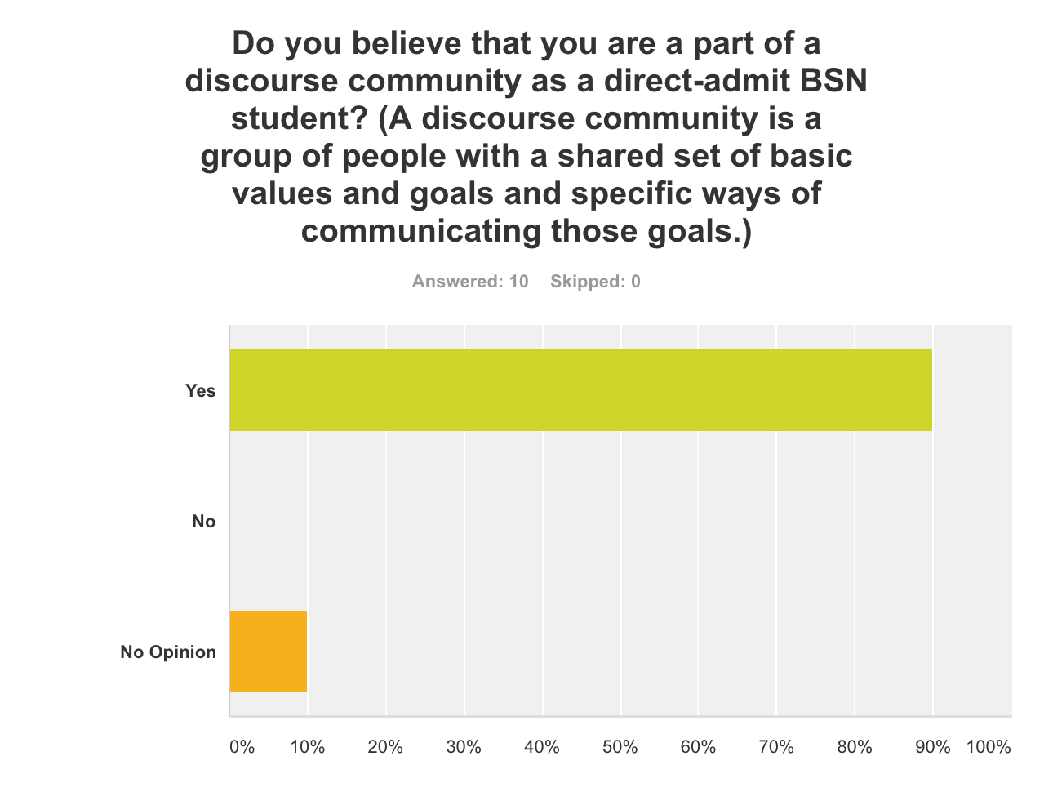
Graphical analyses of some survey questions:

