Samantha Branham
Professor Vaughn
ENGL 2089
3 March 2017

The Best Way to Cheat Death Is to Embrace It: Examining Writings on Euthanasia in the Modern Age
Death is always a difficult subject to talk about. Humans tend to be afraid of the dark, of falling, of the unknown, and death encapsulates the whole scope of human phobia. Because of this, the idea of wanting to die is almost unthinkable to the human mind, even if it is in the face of terminal illness. Yes, suicide is always a complicated issue, but within the medical community, death is a way of life and medically-assisted suicide is a current and pressing issue. The gravity of such matters makes euthanasia an intriguing topic for writers and researchers. Documenting such morbid matters requires an author to have a firm grasp of language and rhetorical appeals in order to argue a point or convey a message with humility and respect, and there is no dearth of writing on the subject. There is, of course, a variety of styles in which an author can write about assisted suicide, from scholarly texts to narrative accounts intended for the masses.
Written and spoken texts are categorized by genre, which is a particular way of conveying language. A genre is defined by specific components, such as research style or sentence structure and is organized in a certain way such that a text is distinguishable to readers as belonging to that genre. Texts about euthanasia tend to fall into one of two kinds of genres, as do most medical texts in general. There are texts that are written in a purely formal and scientific style, designed to be read by subscribers of a medical or health journal, and there are texts written in an informal, biography-style account, intended for a more general audience. Of course, there are also sources that do not fall into either of these distinct categories or those that blend elements of both. The genre in which a text is written shapes how the story is told; many authors can write in many genres about the same topic and, yet, each text will be perfectly unique.
Perhaps the most obvious sign for which source falls into which genre is the word choice and syntax employed by the author(s). Rachel Aviv’s article, “The Death Treatment,” is an account of a woman named Godalieva De Troyer’s lifelong struggle with mental illness, her ultimate decision to be euthanized, and the ripple effect that her decision had on those around her. Though lengthy, this article is made up mostly of short simple sentences punctuated by the occasional longer, clause-ridden sentence, especially when Aviv is describing a major narrative point. This tendency is extremely evident in a paragraph where Aviv introduces the doctor, Wim Distelmans, who euthanized Godalieva, with a short sentence consisting of eleven words followed by a long-winded sentence of more than forty words:
Since [2002], he has euthanized more than a hundred patients. Distelmans, who wears leather coats and boots and artfully tossed scarves, has become a celebrity in Belgium for promoting a dignified death as a human right, a “tremendous liberation,” and he gives talks at cultural centers, hospitals, and schools around the country (Aviv).
The article is also peppered with direct quotes and descriptive imagery that detail the life story of Godalieva until her death by euthanasia in 2012. Aviv uses quotes from Godalieva’s journal as much of the imagery at the opening of the article to describe her depressive state of “‘dark grey…very black…black!’” and relies on creative word choice to paint poignant pictures of Godalieva’s late parents as “domineering and cold…unhappy in marriage, remind[ing] her of a slave” (Aviv). These descriptions give readers an idea of Godalieva’s state of mind as she began to consider euthanasia, much like any good piece of creative writing. Narrative style is frequently dictated by imagery and long-winded descriptions such as these, and Aviv’s article is no exception to the rule.
Lieve Van den Block and her colleagues’ article, “Euthanasia and Other End of Life Decisions and Care Provided in Final Three Months of Life: Nationwide Retrospective Study in Belgium,” has a far different style of writing. This article comes from the BMJ (formerly, the British Medical Journal) and is a study in which researchers collected information from medical doctors in Belgium over the course of two years. They asked the doctors to keep track of all “non-sudden” patient deaths and the circumstances surrounding the deaths. In this article, the sentences are much longer on average, with the first sentence alone having thirty-three words. For comparison, Aviv’s opening sentence has just eleven words. Van de Block, et al.’s article also employs far less flowery language, instead having the typically dry language of a scholarly article, chock-full of research jargon, such as, “univariate associations…[and] multivariate logistic regression analysis” (3). To readers who are not familiar with the research surrounding medical-related discourse communities, this vocabulary may make little sense, as it is written for medical professionals rather than just the general public; the lexis is not compatible with the general public’s linguistic habits. There is also a staunch lack of “flowery” language and lengthy descriptions in this article, as is the norm for scholarly sources.
David Muller’s article, “Physician-Assisted Death Is Illegal In Most States, So My Patient Made Another Choice,” is technically a scholarly piece, as it was originally published in a journal for medical professionals. However, it is also written far more informally than the article by Van den Block, et al. and can be accessed by the public on the Health Affairs website. In this article, Muller talks about an elderly patient he once cared for, Charlie, who desired a peaceful escape from a life of physical pain and suffering. However, in the state in which Charlie lived, euthanasia was illegal so Charlie made the decision to stop eating and drinking instead. Muller’s article is, in general, an intermediate between the polar opposite genres of the other texts. The syntax is more varied than the other two articles; the first sentence is very long, at twenty-six words, but the following sentences are much more bite-sized. One sentence in the body of the essay has just three words: “Charlie was disappointed” (Muller 2346). This article is styled as a narrative and though its author is a medical doctor, the writing style is reminiscent of Aviv’s piece through Muller’s narrative of his patient’s history.
Muller defines much of the medical jargon he uses in the piece, including an explanation of Oregon’s 1994 Death with Dignity Act and a definition of the DNR acronym, making it a manageable article for the general public should a non-medical person come across it. Yet, Muller’s word choice draws attention to his education level with phrases like, “plagued by misgivings” and “inexperience with palliative…care, and inadequate reimbursement” (Muller 2345). This distinction makes it apparent, then, why the article was included in a health journal rather than a more general source.
Popular sources about controversial issues such as assisted suicide, especially in narrative form, tend to pull on readers’ heartstrings and play with their emotions through the use of pathos. Aviv’s article is no exception to this. Aviv focuses her story on how Godalieva’s decision to die affected those around her, namely her son, Tom. The grief Aviv describes is almost palpable, as Tom “felt his mind shutting down” after learning of his mother’s death and then began to process his anger by meeting with the physician who had euthanized her (Aviv). Perhaps the most heartbreaking aspect of this whole story is when one of Tom’s friends recalls Tom’s discussion with the doctor who euthanized his mother:
“He was screaming, ‘You went along with the madness of my mother! You went along with her tunnel vision, her defeatism. You’ve just taken away the suffering of one person and transposed it to another!’” (Aviv).
In addition to the emotional appeals in the article, Aviv references a slew of research studies and quotes several prominent experts on assisted suicide legislature in Belgium and elsewhere. In this way, she implicitly demonstrates her credibility in writing about the subject. Aviv herself has won awards for her journalism, namely the Scripps Howard Award, which is referenced in her author blurb at the end of the article. This sly appeal to ethos proves to the reader that she is not only able to compile appropriate research, but she also has expertise with writing.
Muller’s piece similarly employs pathos as he describes his own personal experience with a patient who desired to be euthanized but had no legal means of doing so in the state in which he lived. Muller describes Charlie’s “severe, unrelenting pain every day for the past three years” due to ailments like spinal stenosis, hearing loss, and visual problems (Muller 2344). After a particularly bad fall resulting in a broken hip, Charlie made the firm decision to stop eating and drinking, resulting in his slow and painful death over the next eleven days until he finally passed away:
Seven days after the fall, having taken only pain medication and rare sips of water, Charlie was still awake enough to tell me that he wasn’t afraid of death; he welcomed it. He still had some pain but was generally comfortable. At home, and with his wife by his side, he was at peace and felt in control, something he valued above all else (Muller 2346).
Muller expresses that dying in such a fashion takes “far more time than most people expect” (Muller 2346). It is evident that the audience of this article, regardless of who they are, can relate to the heartfelt emotions present in Charlie’s story. Much like Aviv’s article, this inspires readers to feel sympathy for the individual who desires a relatively quick and painless death, as well as for the family members impacted by such a decision.
Muller does not directly address his own credibility, except for stating his occupation, but it is apparent that he has knowledge of the issues he is writing about, as this article was featured in a health journal. Additionally, his short biography at the end of the article details his credentials as a dean at the Mount Sinai School of Medicine. Muller also appeals to ethos more subtly, through his knowledge of various medical terms and legislation, including the Death with Dignity Act that Aviv also details in her own article. Unlike Aviv, however, Muller also appeals heavily to his readers’ logic. He insinuates that medical issues like “depression, incontinence, and anything to do with sex” frequently cause embarrassment in patients, so it should be the physician’s duty to initiate conversations about such matters (Muller 2345). He goes on to connect this to euthanasia, using parallel examples of discussing incontinence with an elderly patient in a respectful and open way and discussing the desire to “control the circumstances of [one’s] own death” that many elderly individuals have by exemplifying:
“Mrs. Jones, it’s not uncommon for women your age and with your medical history to sometimes have accidents with their urine. This might be something you’ll never have to deal with, but if it’s ever a concern, I hope you feel comfortable telling me about it. I’m comfortable discussing it, and there are actually a variety of things that can help.”
“Charlie, it’s not uncommon for someone in your condition to think about wanting to control the circumstances of his own death. This might be something you’ll never have to deal with, but if it’s ever a concern, I hope you feel comfortable telling me about it. I’m comfortable discussing it, and there are actually a variety of things that can help” (2345).
Logically, he claims, these two medical situations are the same and we as a society should make strides to see them as such.
Aviv’s and Muller’s articles are much more closely related to each other than to Van den Block, et al.’s research article. Whereas Muller and Aviv employ emotion-arousing strategies, Van den Block and her colleagues take a much more clinical approach that does not directly stimulate sympathy in their readers. Instead, the authors of this study rely mainly on logical appeals through their research, which examines euthanasia care in Belgium. Van den Block and her colleagues detail their methodology for surveying medical professionals who provide euthanasia care to determine factors like the “goal of patient treatment” and “content of end-of-life care,” as well as more specific factors like the “presence of a specialist multidisciplinary palliative care service” (2). Through this glut of information, the authors’ appeals to logos are unavoidably obvious. Unlike Muller’s and Aviv’s articles, Van den Block, et al. also include a variety of tables and charts, as well as an array of statistical data, to back up their research. Also unlike the other articles, the authors of this study have their titles and distinctions prominently listed at the beginning of the paper. Each author’s credibility is apparent by their positions as professors and researchers in various fields of study, including anthropology, communications, and public health (1). The reference list for their article, which is a full page, makes it obvious the researchers involved in the study have extensive knowledge of their material. For comparison, neither of the other articles I studied had a reference page. Readers of these articles would perhaps automatically assume Van den Block, et al.’s article is more scholarly than the others, simply because the authors cited so many sources.
The three sources I examined all discuss the reasons a person might choose euthanasia in different ways, as each genre has a different purpose in contributing to the debate. As a purely scientific study, Van den Block and her colleague’s study compiles data on the numbers of assisted suicides in Belgium over the course of the study and further provides information on some specifics, including involvement of healthcare professionals (5-6). The article does not much focus on external factors like family support, social views on euthanasia, or reasons for disparities in numbers of euthanasia cases between various countries. The reason for this is likely because the article is based in medical research and so the authors were not particularly interested in the non-medical aspects of the issue. As a study written in a scholarly genre, the numerical and statistical data about the numbers of assisted suicides obtained over two years is more important for the researchers to elucidate than the sociocultural factors leading to decisions involving euthanasia.
Muller, on the other hand, looks more on the political debate behind euthanasia, citing various state laws on the subject. He also addresses the personal struggles and feelings of “foolishness” and frustration in a “sudden loss of independence” many elderly patients face when examining their options (2345). It would appear his purpose is to have his readers see the human side of the debate around euthanasia in order to understand that it is not just a black-and-white issue. Narrative-style genres typically have this goal of “appealing to humanity” to make a point. Aviv, too, addresses the personal side of euthanasia and the current political debate on the matter, though she is more concerned with the country of Belgium than with the United States.
Aviv heavily focuses on how a person’s emotional state influences the decision to die as the subject of her narrative, Godalieva, makes her decision “based on psychological distress,” with her physician seeing medically-assisted suicide as “a human right…[and] a ‘tremendous liberation’” (Aviv). In Belgium, individuals can request euthanasia for psychological disorders as well as somatic illnesses, so one’s emotional state plays an important role in the euthanasia debate there. Aviv also addresses the sociopolitical characteristics of Flemish society that lead to euthanasia being painted in a more neutral light than in the United States. Some people even think the country suffers from a “crisis of nihilism created by the rapid secularization of Flemish culture” (Aviv). Unlike the United States, Belgium does not integrate religion so tightly into its policy and views on life-or-death topics like euthanasia are not as controversial. Again, her purpose seems to open her readers’ minds enough to sympathize with the plight of those seeking euthanasia. As a popular source in a narrative genre, this is not unexpected.
It is not surprising that the more narrative-heavy sources I studied looked at different sociocultural aspects than the purely scholarly source. The disparity in genre between the sources likely accounts for much of this; scholarly pieces are typically detached from the emotional or inherently social aspects of a topic, while pieces discussing an individual’s experience usually address these aspects more in depth.
Evidently, differences in genre account for different accounts of the same topic. Euthanasia is a deeply personal issue but it is also imperative to study this issue from a research standpoint to acquire valuable data about it. The sources I examined showed breadth and depth in their study of assisted suicide. Hotbeds of controversy like these must be examined in multiple unique ways in order to have the best understanding of the issue at hand.

Works Cited
Aviv, Rachel. "The Death Treatment." The New Yorker. The New Yorker, 14 June 2015. Web. 13 Feb. 2017.

Block, Lieve Van Den, Reginald Deschepper, Johan Bilsen, Nathalie Bossuyt, Viviane Van Casteren, and Luc Deliens. "Euthanasia and Other End of Life Decisions and Care Provided in Final Three Months of Life: Nationwide Retrospective Study in Belgium." BMJ 339.2 (2009): 1-8. Web. 24 Feb. 2017.

Muller, David. "Physician-Assisted Death Is Illegal in Most States, So My Patient Made Another Choice." Health Affairs 31.10 (2012): 2343-2346. CINAHL Plus with Full Text. Web. 13 Feb. 2017.

Sources:
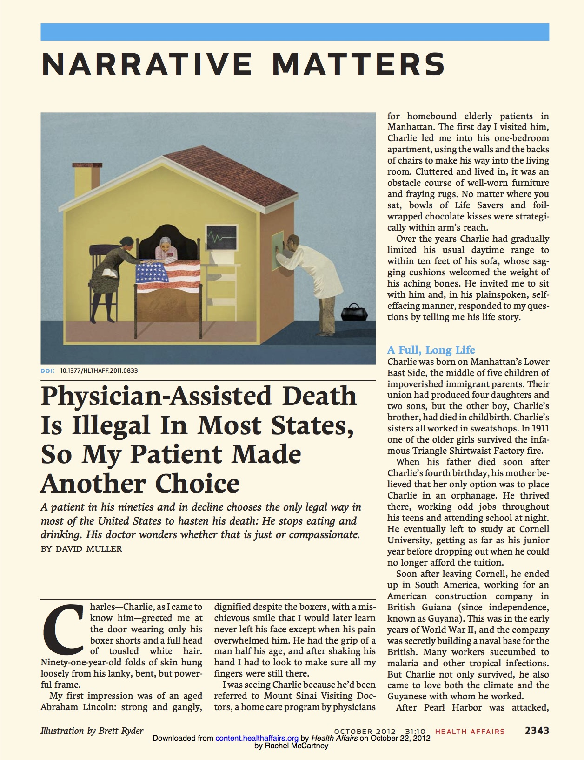
New York Times article: http://www.newyorker.com/magazine/2015/06/22/the-death-treatment

Health Affairs journal article:

BMJ article: