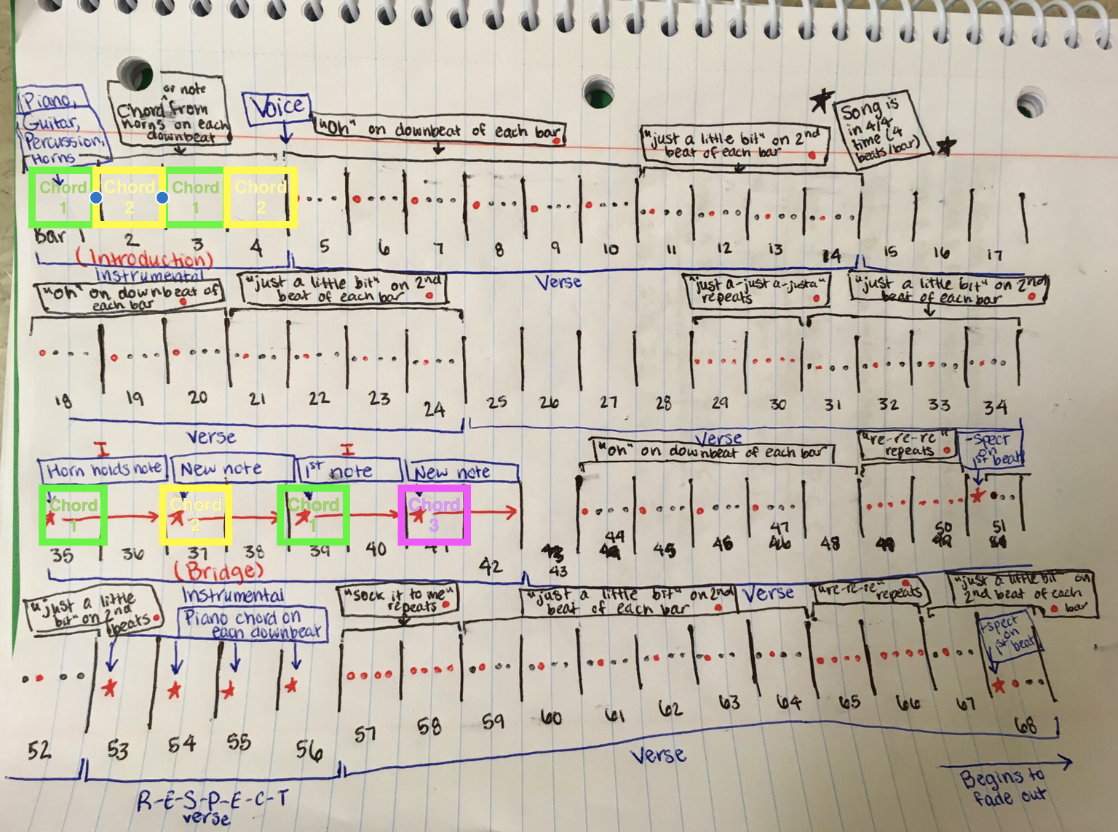

Analysis of “Respect”
Aretha Franklin’s 1967 song, “Respect” displays a diverse array of musical techniques and blends several genres to create a powerful ballad of confidence and self-respect. In under two and a half minutes, this song manages to impart valuable lessons that remain as important today as they were upon the song’s release fifty years ago.
It is vital to view this piece of music in terms of its historical context. “Respect” was originally written by Otis Redding during a period of social conflict in the United States. The 1960s were a time of unrest and division among many social groups. When Franklin’s version of “Respect” was released for public consumption, the United States was engaged in the Vietnam War overseas and the Civil Rights Movement at home. As a black woman, Aretha Franklin faced discrimination for both her gender and her race. “Respect” was a song about a woman telling her male partner he needed to respect her or she was going to leave him. Such a message must have seemed rather bold and even scandalous upon its release. For women at the time, especially black women, it was a message of empowerment in a society which allowed them little power.
“Respect” is a song that falls into the different – although related – African-American genre of soul and industry-based stream of rhythm and blues (R&B). R&B is somewhat of a general commercial term that, at the time, encompassed multiple African-American genres. Franklin’s song has elements of R&B through its use of sliding vocals, free pitches and rhythms, and the blues style present in the verses. The first two lines of each verse are very similar lyrically while the third is different, although the verses do not fit the typical 12-bar schematic of blues. “Respect” is also undeniably an example of soul music. Franklin began exploring her passion for music by singing gospel in her father’s church when she was young. Gospel music, of course, was a major inspiration in the formation of soul. This gospel style is evident in “Respect” as Franklin and her backup singers engage in a sort of call-and-response, with the backup singers adding interjections (“ooh,” “re-re-re-re,” “just a little bit”) throughout the song as Franklin supplies the lyrics for the verses. Additionally, the end of the song has a gospel feel, as the final few lines repeat while the sound fades away gradually. These features are common in many black gospel songs, especially in church with each member of the congregation adding their own interjections to the main melody.
Like much popular music, “Respect” has a simple 4/4 meter. There is a lot of familiarity in the piece; for example, the “ooh” from the background singers falls on the downbeat of each measure. Each “just a little bit” falls on the second beat of the measures in which it is sung. Too much familiarity in a piece of music can become boring, so there are also sections of “Respect” that are different from the main structure of the song. The song begins with an instrumental introduction of four measures, before Franklin begins singing for the next thirty measures (three verses) or so. Then, the listener gets to hear a fresh portion of the song, as it transitions into an instrumental “bridge” for eight measures. There is some repetition here as the horns play one chord for two consecutive measures, repeating this process four times. However, though the first and third chords are the same, the second and fourth are different from the first and from each other. This brief instrumental allows the listener to fully appreciate the horns’ music on their own between sections with Franklin’s singing. Franklin sings for another verse, followed by the “R-E-S-P-E-C-T” verse. This short section again presents a musical change for the listener, which is important among the repetition in the song. Franklin then sings one final verse, accompanied by her backup singers, and the song fades into silence.
The “R-E-S-P-E-C-T” section is iconic for many reasons. Though the song doesn’t have a true chorus, this verse seems to be the most memorable for those who are familiar with the song and, like a typical chorus, it is the part of the song that everyone seems to know, even if they don’t know the rest of the words. In this verse, there is almost no instrumentation to accompany Franklin’s vocals. There is instead simply one piano chord played on the downbeat of each of the four measures. Franklin herself played the piano for this recording, so this verse is solely her own. From a referentialist (and sociocultural) perspective, these measures give Franklin the power to be in charge in a society that harshly limited her actual power in society. By demanding her partner give her respect and by acknowledging that she knows how to take care of business (TCB), Franklin asserts herself as a strong and independent woman who will accept nothing less than respect. From an expressivist standpoint, “Respect” seems to have been designed to let female listeners and especially black female listeners feel that they have the power to also demand respect from those around them. The belting vocals and commanding lyrics instill a sense of confidence and self-empowerment in the audience.
In a society that does not grant women and minorities the respect they deserve to this day, “Respect” remains relevant. Franklin’s powerful voice and words speak to those in society who need someone to give them the confidence to demand respect. Though it targets certain groups of people, the song can be enjoyed by a wide audience because of its funky beat and catchy lyrics.

